ASSIGNMENT 2

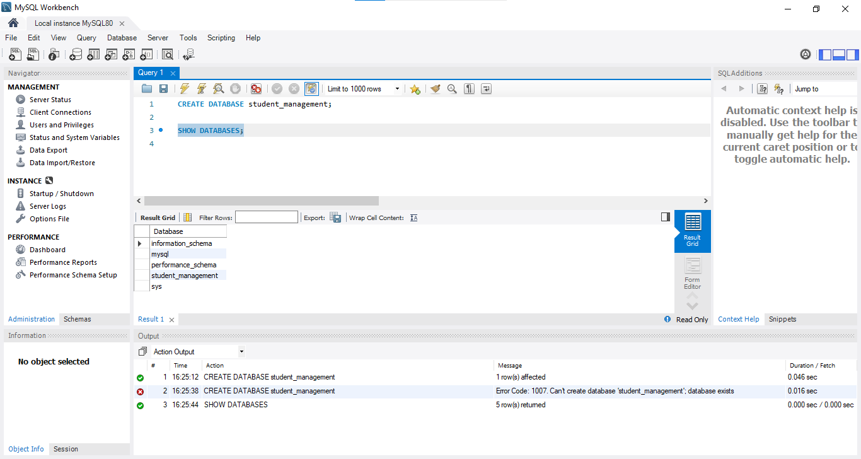

1. Create a Table with Constraints

Create a table named students_info with the following structure and constraints:

student_id should be the primary key.

student_name should not be NULL.

course_enrolled should not allow NULL values.

course_progress (float, no constraints)

is_active (boolean, no constraints)

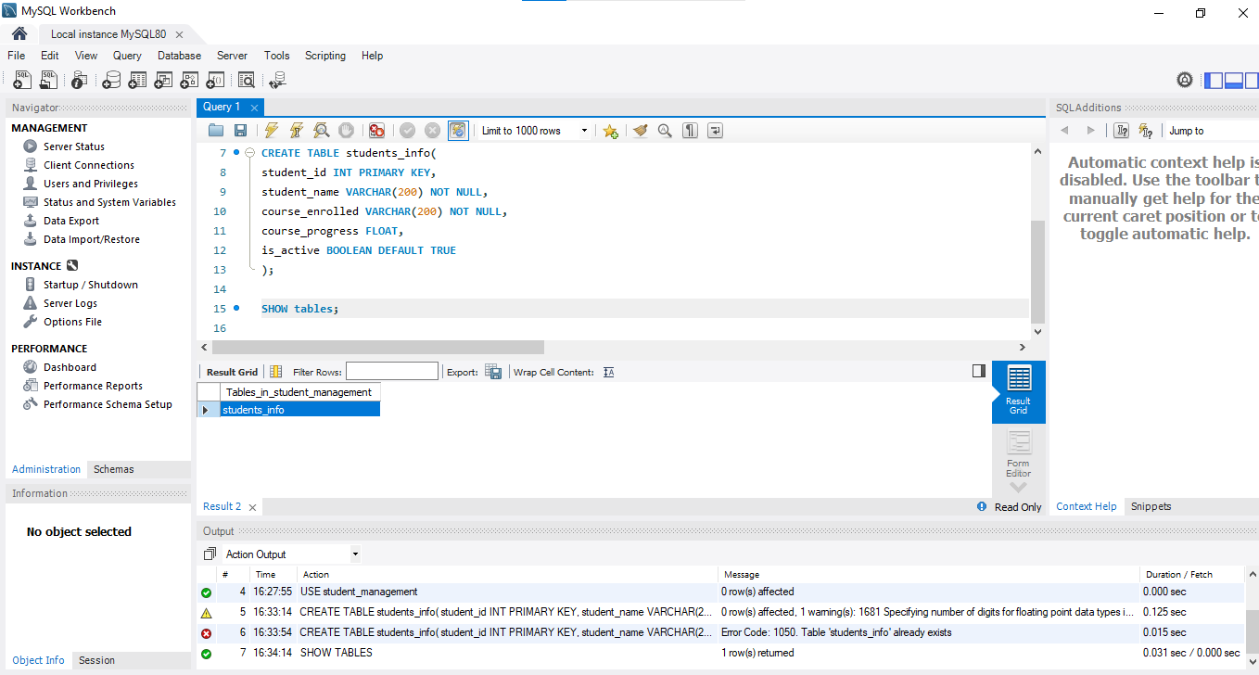

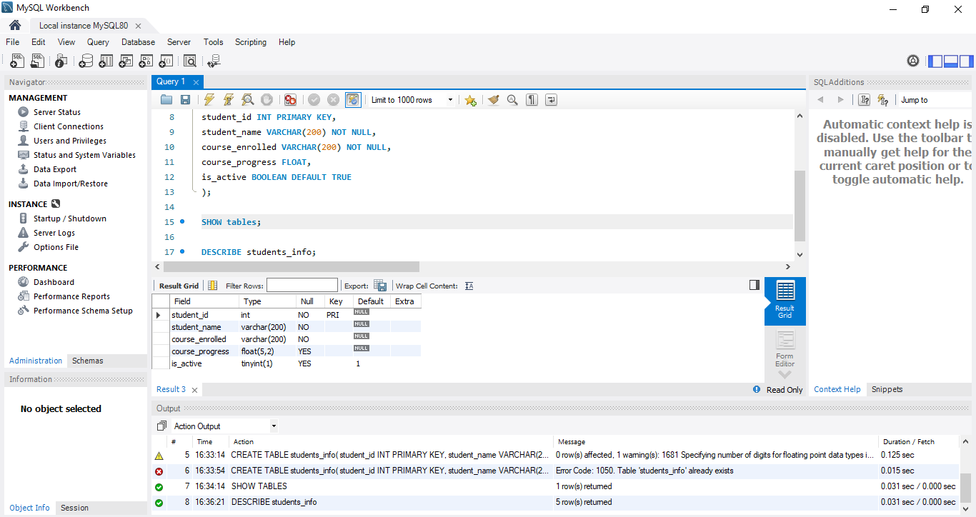

1. Add a New Column

Add a new column email of type STRING to the students_info table.

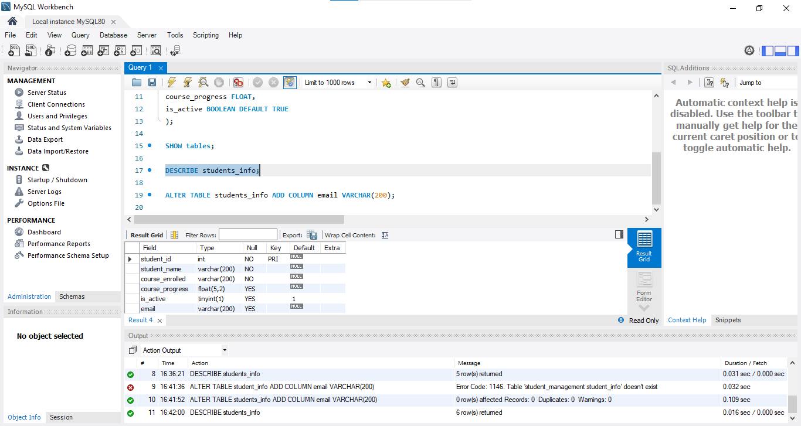

1. Modify a Column

Modify the course_progress column to restrict its values to only two decimal places.

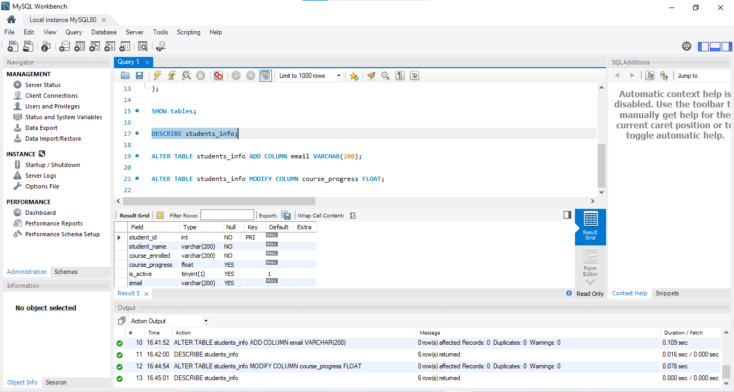

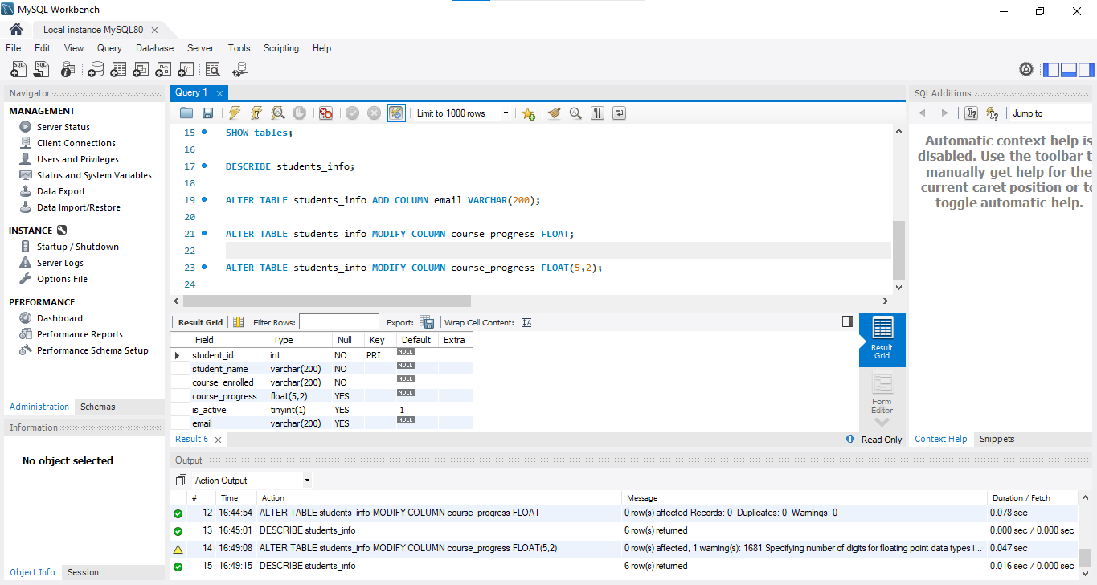

1. Add a UNIQUE Constraint

Add a UNIQUE constraint on the email column to ensure that no two students can have the same email address.

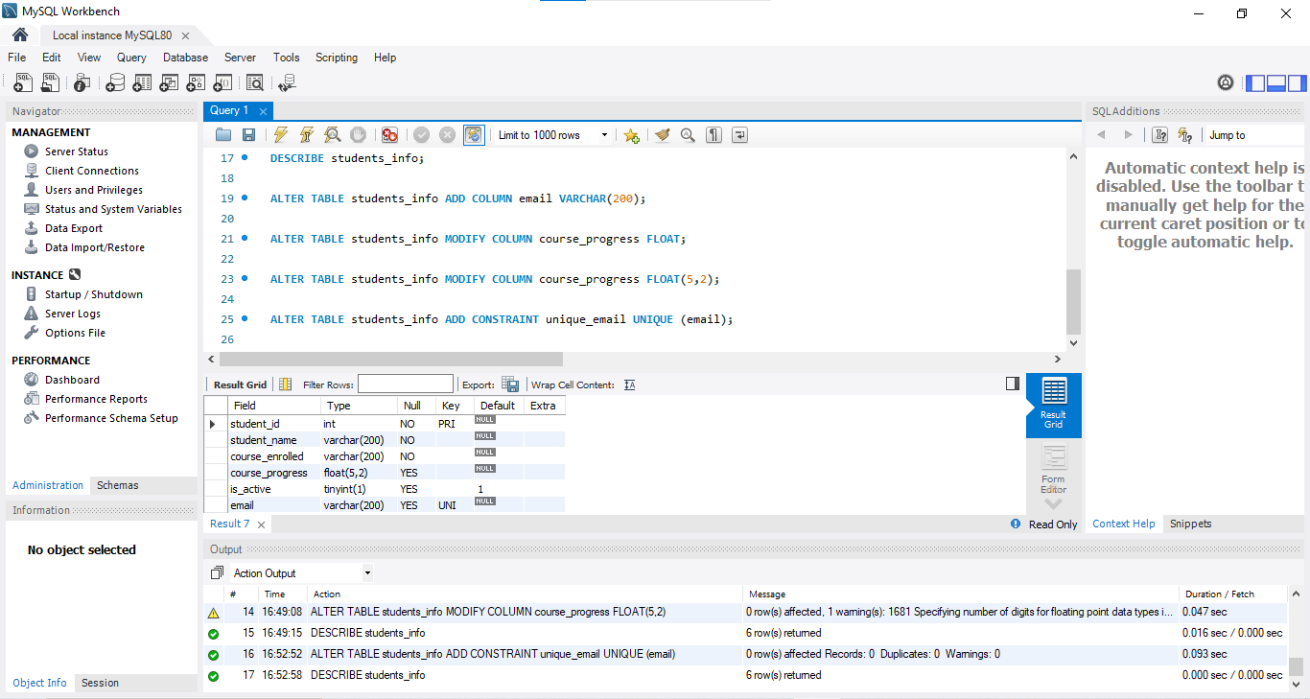

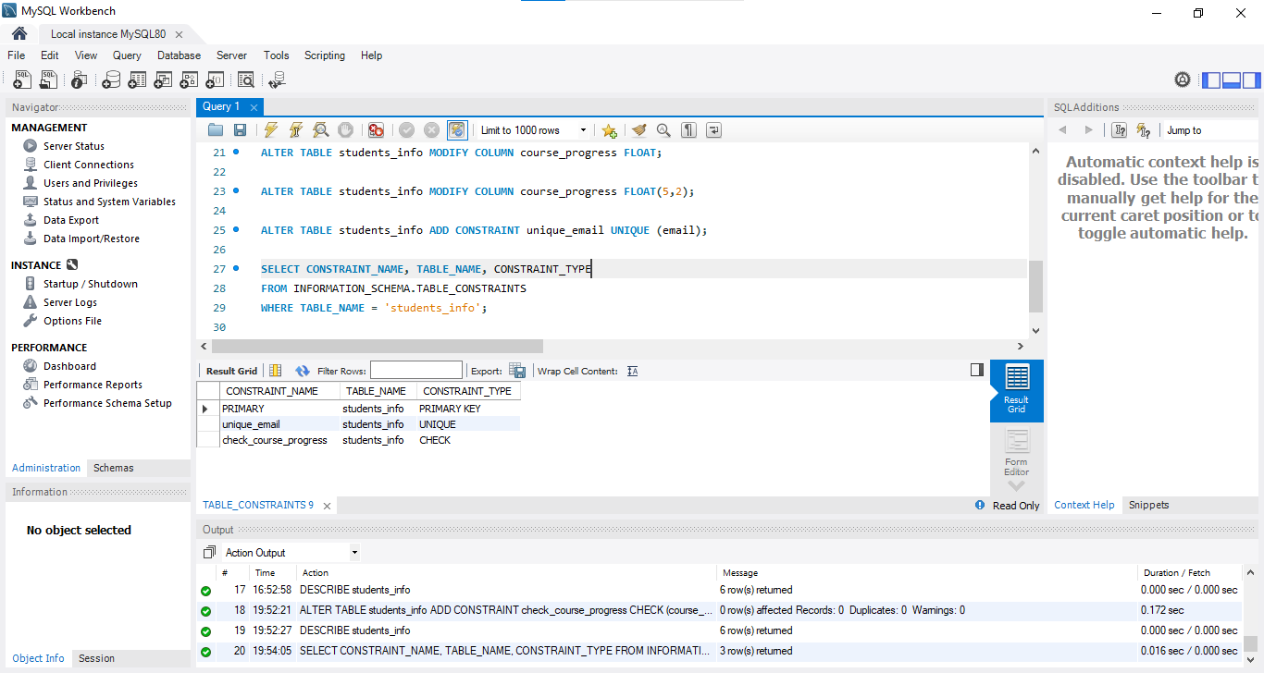

1. Add a CHECK Constraint

Add a CHECK constraint to ensure that the course_progress is always between 0 and 100.

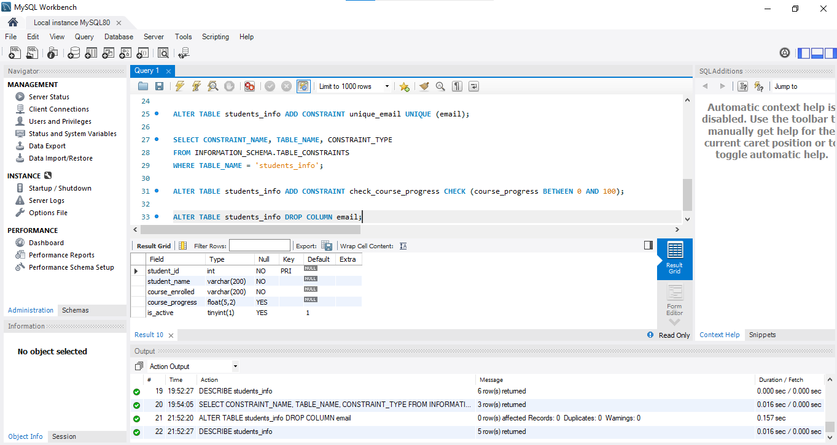

1. Drop a Column

Drop the email column from the students_info table.

1. Rename a Column

Rename the student_name column to full_name.

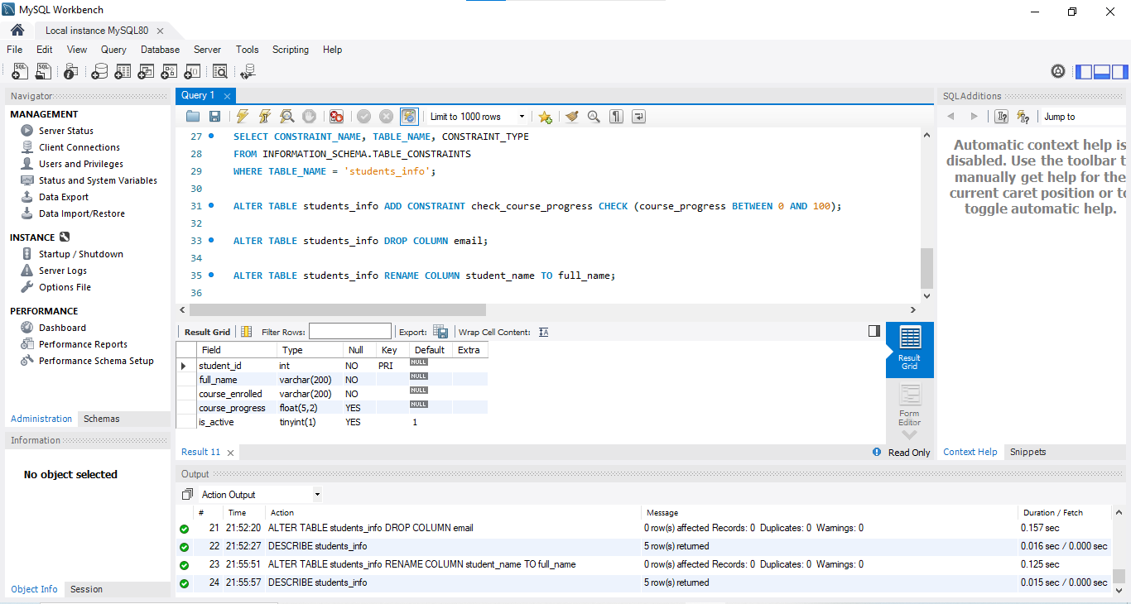

1. Add a Default Value

Add a default value of TRUE for the is_active column to indicate that students are active by default.

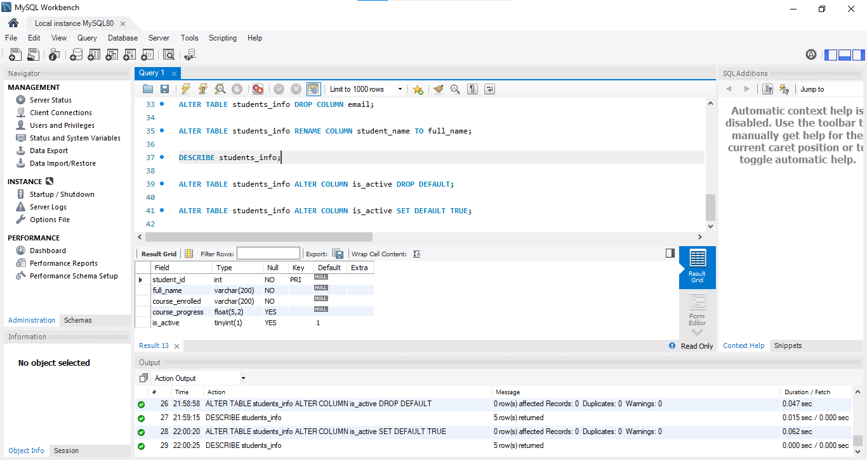

1. Drop a Constraint

Drop the check_course_progress constraint from the students_info table.

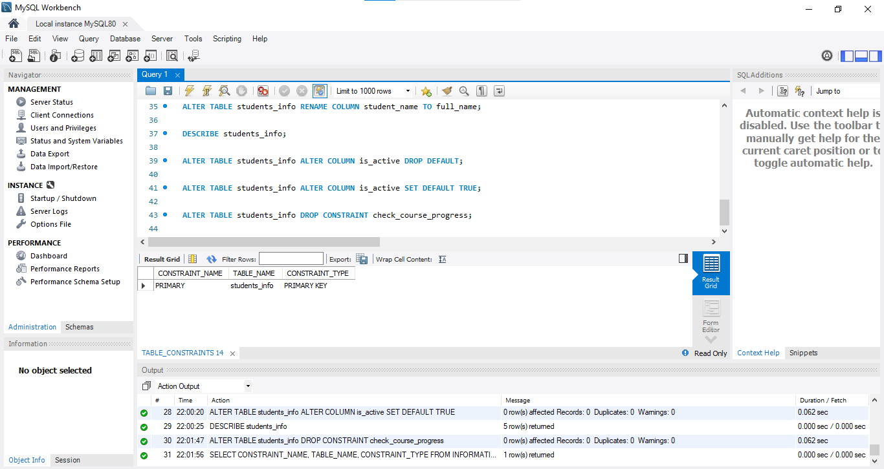

1. Truncate the Table

Remove all data from the students_info table without deleting the table.

